Table of Contents
Introduction 2
Open Loop Settings for Fortress Batteries with Schneider Inverters 3
Open Loop Settings with Schneider Charge Controllers 5
Closed-Loop Setup between Fortress Batteries and Schneider Conext Gateway/ Insight Facility 6
Closed-Loop Setup between Fortress Batteries and Schneider Insight Home 7
Appendix 9
Exhibit A 9
Exhibit B 10
Exhibit C 11
Exhibit D 12
Exhibit E 13
Error! Hyperlink reference not valid.
Error! Hyperlink reference not valid.
Error! Hyperlink reference not valid.
Error! Hyperlink reference not valid.
Error! Hyperlink reference not valid.
Error! Hyperlink reference not valid.
Error! Hyperlink reference not valid.
Error! Hyperlink reference not valid.
Error! Hyperlink reference not valid.
Error! Hyperlink reference not valid.

Introduction
This integration guide will help set up the charge/discharge parameters of Fortress Power batteries as they relate to Schneider inverters, as well as the setup of closed-loop communication between the Fortress batteries and Schneider inverters. Please note that only the Schneider XW Pro and Gateway support running the batteries in closed loop communication mode, and that the inverters will still need to be programmed in the open loop settings before setting up closed loop communication.
For any additional help, please contact techsupport@fortresspower.com

Open Loop Settings for Fortress Batteries with Schneider Inverters
Charger Setting > Custom Setting
 | 80% DoD, 6000 cycles | 90% DoD, 3000 cycles
Battery Type | Custom
Charge Cycle | 2StgNoFloat
Bulk Voltage | 54.4 V | 54.6 V
Max Bulk Current | eFlex:55A per battery  eVault:100A per battery  eVault MAX 150 per battery  LFP-10: 70A per battery | eFlex: 60A per battery  eVault:150A per battery  eVault MAX: 180A per battery  LFP-10: 80A per battery
Max Discharge Current | eFlex: 60A per battery  eVault: 160A per battery  eVault MAX:  LFP-10: 100A per battery
Battery Capacity | eFlex: 105AH per battery  eVault: 360AH per battery  eVault MAX: 360AH per battery  LFP-10: 200AH per battery
Max Charge Rate Percentage (%) | eFlex:60A per battery  eVault:100A per battery  eVault MAX 150 per battery  LFP-10: 70A per battery  Divided by Total Inverter DC Amperage | eFlex: 60A per battery  eVault:150A per battery  eVault MAX: 180A per battery  LFP-10: 80A per battery  Divided by Total Inverter DC Amperage
Default Battery Temperature | Warm
Recharge Volts | 51.3
Grid Support Volts** | 53
Absorb Volts | 54.4
Absorb Time | 1 Hour
Charge Block Start | Default
Charge Block Stop | Default
Advanced Settings > Inverter Settings
Low Battery Cut Out Voltage | 48V (50V if allowed)
LBCO Hysteresis | 2.0V
LBCO Delay | 5 Sec
High Battery Cut Out Voltage | 61V (58V if allowed)
Search Watts | Default
Search Delay | Default

**The Parameter Setting for Grid-tie Sell Mode:
In a DC coupled system, Grid Support or Enhanced Grid Support mode supplies PV power to the loads and sells surplus power to the grid. This mode of operation keeps the batteries as completely charged as possible. The Enhanced Grid Support only works with lead acid batteries, please disable it when you use Fortress batteries.
Grid Support Mode is used for the systems with DC Sources not communication over Xanbus.
Advanced Setting > Inverter Settings
Charger | Enabled
Enhanced Grid Support | N/A
Grid Support | 54V (site specific)
Recharge Volts | 51.3 V
Sell Mode | Enabled
Max Sell Amps** | PV array size ÷ 240V ÷ total inverter output kW
Advanced Setting > Charger Setting
Recharge Volts | 51.3 V
** For example, if the system has a 10 KW PV array and 2 of XW+ 5848 inverters, the Max Sell Amps per inverter will be 10,000W/240V/2 = 21A
Grid Support Voltage Note: The grid support voltage will “sell back” the battery to the grid side of the battery inverter when voltage meets the programmed threshold. This is a user specific setting – some users will want to use more battery capacity for selling back, and others will want a full battery before selling back. Selling back at 54V will keep the battery mostly full. Users on reliable power grids wanting to sell back for evening peak utility rates may prefer to lower grid support to allow the battery to more deeply discharge at night (suggestion:52.5V).
Recharge Voltage Note: A battery voltage near 51.4V indicates an approximate 20% state of charge. As such, the inverter is programmed to recharge the battery from an AC power source (grid or generator) when the battery reaches a 20% SoC. This voltage setting can be increased to allow for more reserve capacity in the battery.
AC-coupled note: AC coupling an appropriately sized solar array on the backup side of the Schneider inverter will automatically charge the batteries. AC-coupling on the grid or supply side of the Schneider inverter will charge the batteries only when the battery bank reaches the inverter recharge voltage.

Open Loop Settings with Schneider Charge Controllers

Parameter Setting for Fortress Batteries with Schneider XW+ MPPT 60/80
Advanced Setting > Charger Setting
Battery Type | Custom
Custom Setting
 | 80% DoD, 6000 cycles | 90% DoD, 3000 cycles
Charge Mode | 3 Stage
Eqlz Support | Disabled
Bulk Voltage | 54.4 V | 54.6 V
Absorb Voltage | 54.4 V | 54.6 V
Absorb Time | 60 minutes
Float Voltage | 54.4 V
Battery Temperature Compensation | 0mV/C
Battery Capacity | eFlex: 105AH per battery  eVault: 360AH per battery  eVault MAX: 360AH per battery  LFP-10: 200AH per battery
Max Charge Rate Percentage* | eFlex:55A per battery  eVault:100A per battery  eVault MAX: 150A per battery  LFP-10: 70A per battery  Divide by total CC amp output | eFlex: 60A per battery  eVault:150A per battery  eVault MAX: 180A per battery  LFP-10: 80A per battery  Divide by total CC amp output
Charge Cycle | Warm
Recharge Volts | 53 V
Absorb Time | 1 Hour
Default Battery Temperature | Warm
Battery Voltage (Auto-detected) | 48V

Note: The charge controllers can be set to a 3 stage charging cycle, but the inverter should be kept in a 2 stage charging cycle. Doing so, as well as setting the charge controller recharge voltage to be greater than that of the inverter recharge voltage, will prioritize charge controller charging over the inverter charging. Inverter charging is a grid/generator charge which has a lower priority than solar charge controller charging.

Closed-Loop Setup between Fortress Batteries and Schneider Conext Gateway/ Insight Facility
All Fortress Power batteries work in open-loop communication mode—that is, with voltage detection. Closed loop does not exempt the installer from programming the inverter manually. Open loop settings should be programmed before setting up closed loop communication. The inverter will revert to open loop settings if closed loop communication drops.

- Connect communication cables and canbus terminator between the batteries
  - eFlex-specific instructions:
    - RX/TX ports are universal
    - The “master” battery is the one powered up first – so after plugging in the communication cables, turn the battery which will communicate to the Schnieder inverter on first. After the light show completes, push button the next eFlex battery on, proceeding down the chain to the last eFlex with the Canbus terminator. and install a Canbus communicator at the enda CAT6 cable into the eFlex and then into the RJ46 pinout converter (Exhibit A).
  - eVault-specific instructions:
    - Use the TX port on the master inverter to connect to the RX port of the slave inverter.
    - The inverter communication will therefore be plugged into the RX port of the master inverter.
  - eVault MAX specific instructions:
    - set the battery protocol to 1 on the touchscreen
    - plug the RJ45 cable into the battery RS485 port.
    - If three or more batteries are connected in parallel, turn on the 120Ω on the first and last battery. Leave the rest off.
- Modify the communication cable between the master battery and the inverter
  - eFlex-specific instructions:
    - Cut off one end of the ethernet cable and connect wire 7 (brown-white/RJ485A) to port 18 and pin 8 (brown/RJ485B) to port 20 on the Conext Gateway/ Insight Facility (Exhibit B).
  - eVault-&eVault MAX specific instructions:
    - Identify if the RJ45 cable is the A or B format. Typically, the cables are B format. Whichever format, the eVault uses wire 3+5 for RJ485A/B communication.
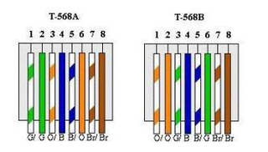

    - Cut off one end of the ethernet cable and connect wire 3 (typically green-white) to port 18 and wire 5 (typically blue-white) to port 20 on the Conext Gateway/ Insight Facility (Exhibit A).
- Power on the batteries and Schneider as usual and connect to the Conext Insight.

- Navigate to Setup -> Device Detection and run detection for RS-485-1 with range 1 to 2. The battery BMS will then appear in the device list, as the Schneider Battery Monitor (Exhibit C).

- Navigate to the Devices -> Inverter\Charger -> Configuration -> Advanced
Charger settings should be set to lithium-ion battery with an charge cycle set to external BMS.
Grid Support settings should be set to state of charge control
Battery Management System settings should be set to Fault on Loss of BMS Status and loss of State of Charge information. (Exhibit D)

- Navigate to the Schneider Devices -> BMS Menu -> Battery Bank 1 -> Apply
Make sure the BMS is associated with Battery Bank 1 by clicking “Apply” (Exhibit E)

Closed-Loop Setup between Fortress Batteries and Schneider Insight Home
- Repeat steps 1-2 from “Closed-Loop Setup between Fortress Batteries and Schneider Conext Gateway/ Insight Facility”.
- Modify the communication cable between the master battery and the inverter.
- eFlex-specific instructions:
- Cut off one end of the ethernet cable and connect wire 7 (brown white/RJ485A) to port 9 and pin 8 (brown/RJ485B) to port 11 on the Insight Home (Exhibit B).
- eVault-& eVault MAX specific instructions:
- Identify if the RJ45 cable is the A or B format. Typically, the cables are B format. Whichever format, the eVault uses wire 3+5 for RJ485A/B communication.
- Cut off one end of the ethernet cable and connect wire 3 (typically green-white) to port 9 and wire 5 (typically blue-white) to port 11 on the Insight Home (Exhibit B).
- Repeat steps 3-6 from “Closed-Loop Setup between Fortress Batteries and Schneider Conext Gateway/ Insight Facility”.

Closed Loop Communication Set-Up using Schneider Gateway

Appendix

Exhibit A

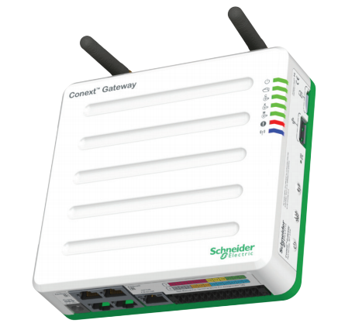

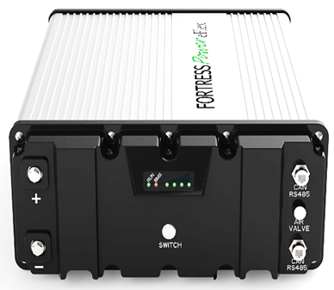
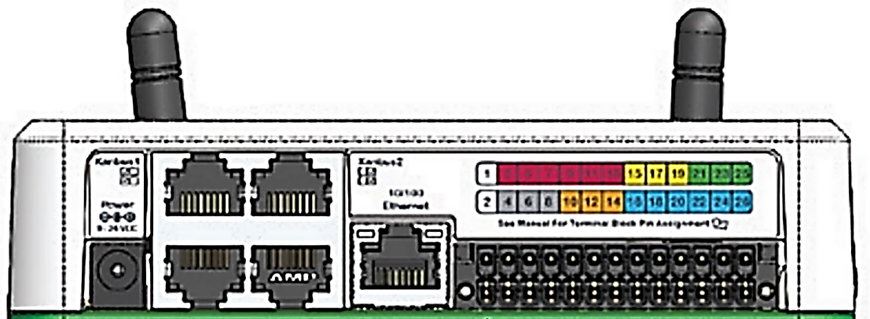

From Battery eFlex eVault
Gateway Port 18 brown-white, wire 7 typ. green-white, wire 3
Gateway Port 20 brown RJ45, wire 8 typ. blue-white, wire 5

Schneider Closed Loop Communication Set-Up using Insight Home

Exhibit B
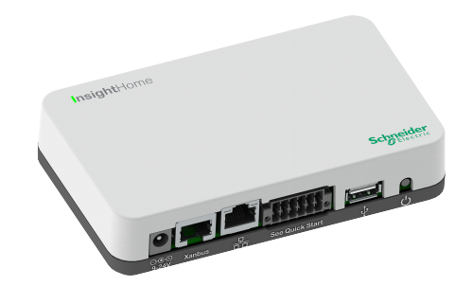
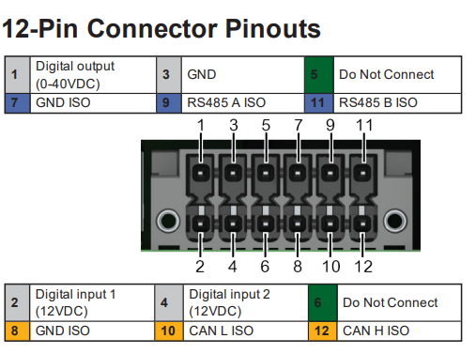
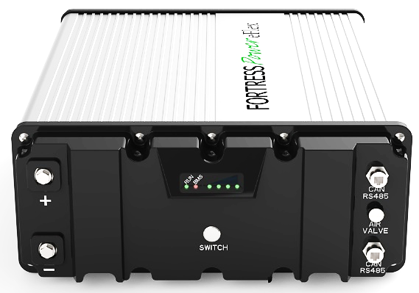
From Battery eFlex eVault
Gateway Port 9 brown-white, wire 7 green-white, wire 3
Gateway Port 11 brown, wire 8 blue-white, wire 5

Exhibit C
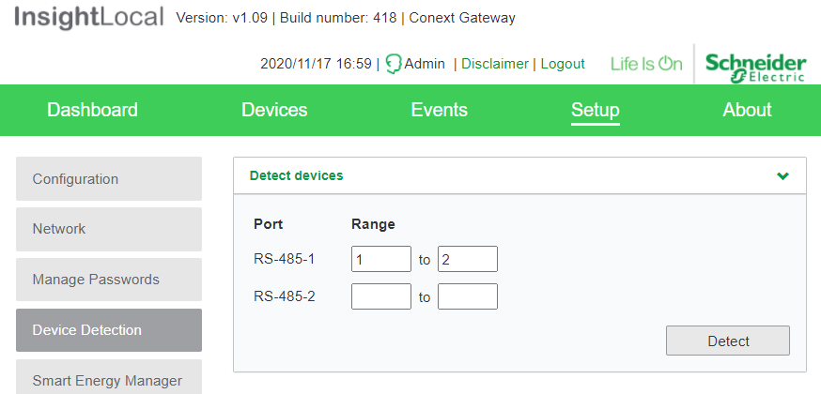

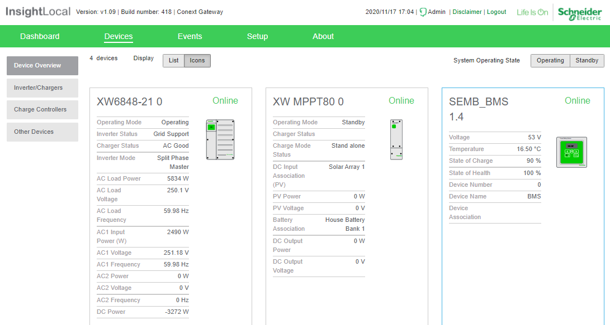
Appears after successful device detection

Exhibit D
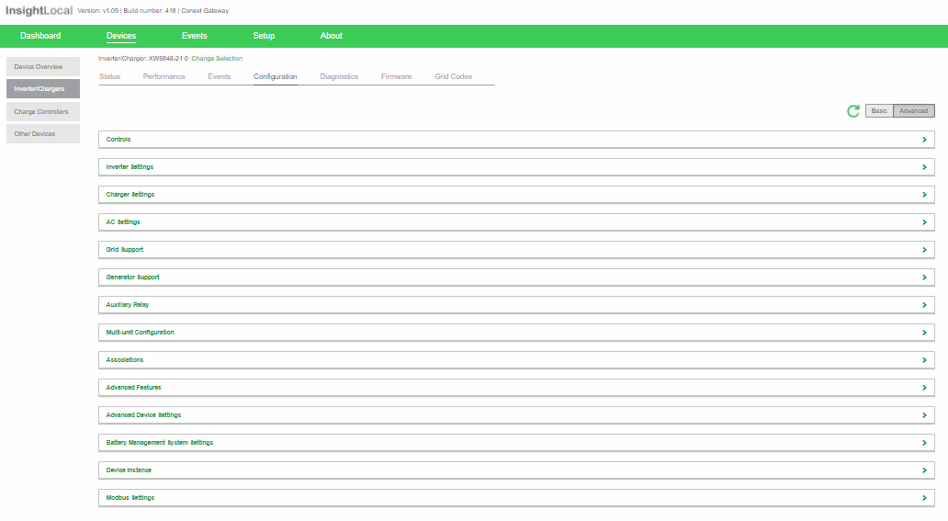
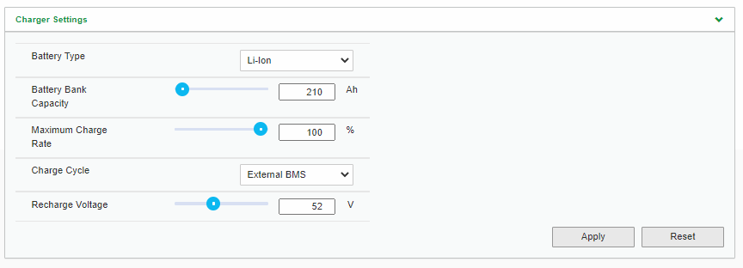
Charge controller recharge voltage should be set higher.
Note: 105 Amp hours per EFLEX
51.5
[Grab your reader’s attention with a great quote from the document or use this space to emphasize a key point. To place this text box anywhere on the page, just drag it.]
Grid support voltage setting is user specific based on sell back amount vs. reserve capacity
Note: XW Pro only - Make sure State of Charge Control is Enabled
53V
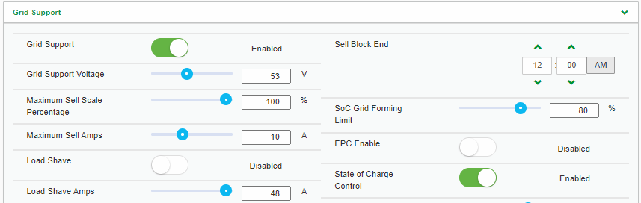
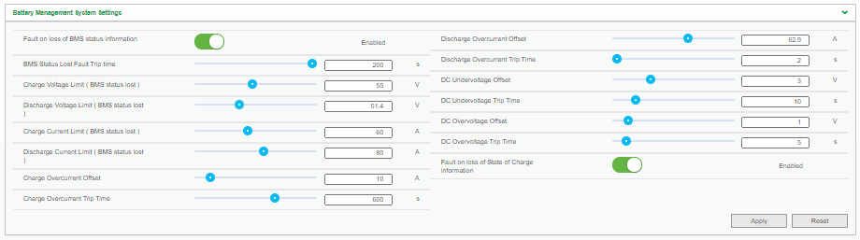
60 Amp Per Eflex
55 Amp Per Eflex
XW Pro only: Enable Fault on loss of BMS Status / State of Charge Information

Exhibit E

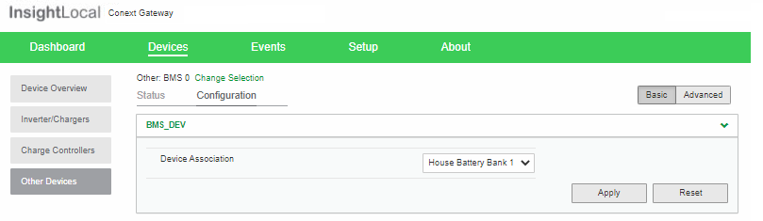
Note: Be sure to click apply”

